Chemistry 141 Name

Dr. Cary Willard

Exam 2B April 2008

Multiple Choice (28 points)

Page 1 (17 points)

Page 2 (19 points)

Page 3 (22 points)

Page 4 (21 points)

Total (107 points)

Percent

Formulas

|  |  |  |
| --- | --- | --- |
| Kinetic energy = ½ mv2  w = -PΔV  ΔG = ΔH - TΔS  w=dxF  C = q/ΔT  ΔGo = -nFEo  ΔG = - RTlnK  E = mc2  E = IR | PV = nRT  Ptotal = P1+P2+P3+…  P1=X1*Ptotal  Ba(Na)2 = fruit  Ptotal = P1 + P2 + P3 + …  M = mol/L  m = mol/kg solvent  Xi = moli/ moltotal  u = (3RT/MW)½  Rate ∝ (MW)-½ | HΨ=EΨ  Amp = C/sec  π= iMRT  E = hν = hc/λ  E = nhν = nhc/λ  M1V1 = M2V2  Psoln = (Psolv)(Xsolv)  ΔTf = i(kf)(m)  ΔTb = i(kb)(m) |



Constants

|  |  |
| --- | --- |
| F = 9.65 x 104 C  h = 6.626 x 10-34 J sec  c= 2.9979 x 108 m/sec  e = 1.602 x 10-19 C  NA = 6.022 x 1023/mol  k = 1.381 x 10-23 J/K  1 kcal = 4.184 kJ  K = oC + 273.16  Kw = 1.0 x 10-14M2 | mass electron = 9.109 x 10-31 kg  Standard Temperature and Pressure = 0oC and 1 atm  R = 0.0821 L atm/mol K= 8.314 J/K mol= 1.987 cal.mol K = 62.4 L torr/mol K  760 torr = 760 mm Hg = 1.00 atm = 101 kPa = 14.6 psi = 30 in Hg |
| Specific heat Al 0.902 J/g K  Specific heat Cu 0.385 J/g K | Specific heat water = 4.184 J/g K  Hvaporization (H2O) = 2260 J/g |

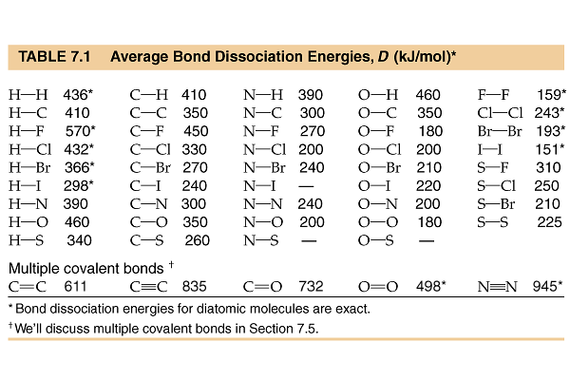

Part I -- Multiple choice questions (28 points)

1. The nutritional calorie (abbreviated Cal) is equal to
   1. 4.184 J.
   2. 4.184 cal.
   3. 1 kcal.
   4. 1 mcal.
   5. None of the above.
2. For which should the standard heat of formation *Hof*, be zero at 25oC?
   1. O2(*g*)
   2. O3(*g*)
   3. O(*g*)
   4. all the above
   5. none of the above
3. Which equation represents the reaction whose *H*, represents the standard enthalpy of formation of CHCl3(*l*) at 25oC? (*i.e.*, for which is *H* = *Hof* of CHCl3)
   1. C(*s*) + 1/2 H2(*g*) + 3/2 Cl2(*g*) 🡪 CHCl3(*l*)
   2. CHCl3(*l*) 🡪 C(*s*) + H(*g*) + 3 Cl(*g*)
   3. C(*s*) + H(*g*) + 3 Cl(*g*) 🡪 CHCl3(*l*)
   4. 2 C(*s*) + H2(*g*) + 3 Cl2(*g*) 🡪 2 CHCl3(*l*)
   5. 2 CH4(*g*) + 3 Cl2(*g*) 🡪 2 CHCl3(*l*) + H2(*g*)
4. For a particular process that is carried out at constant pressure, *q* = 125 kJ and *w* = -15 kJ. Therefore,
   1. ** = 140 kJ and *H* = 125 kJ.
   2. ** = 110 kJ and *H* = 125 kJ.
   3. ** = 125 kJ and *H* = 140 kJ.
   4. ** = 125 kJ and *H* = 110 kJ.
   5. ** = -15 kJ and *H* = 125 kJ.
5. Suppose you needed to closely monitor small changes in pressure inside a container using an open end manometer. For the best accuracy, the substance in the manometer should
   1. be mercury
   2. be a solid
   3. have a high heat capacity
   4. have a low density
   5. have a high density

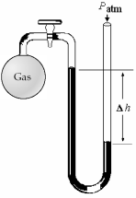

1. What is the pressure (in mm Hg) of the gas inside the above apparatus if the outside pressure, Patm, is 740 mm Hg and the difference in mercury levels, *h*, is 30 mm Hg?
   1. 770 mm Hg
   2. 710 mm Hg
   3. 740 mm Hg
   4. 30 mm Hg
   5. Unable to determine
2. Which statement about real gases is **true**?
   1. Forces of attraction and repulsion exist between gas particles at close range.
   2. The mass of the gas particles is zero.
   3. The behavior of real gases can be exactly predicted using the ideal gas law.
   4. The volume of the gas particles is zero.
   5. All of the above are true of real gases.
3. Some assumptions from the kinetic molecular theory are listed below. Which one is most frequently cited to explain compressibility of a gas?
   1. A gas consists of tiny particles moving in random straight line motion.
   2. The volume of the particles is negligible compared to the volume of the gas.
   3. The average kinetic energy of gas particles is proportional to the Kelvin temperature.
   4. Collisions of gas particles are elastic and total kinetic energy of the gas is constant.
4. Assume that you have a sample of gas in a cylinder with a moveable piston, as shown in diagram (1). The initial pressure, number of moles, and temperature of the gas are noted on the diagram. Which diagram (2)-(4) most closely represents the result of doubling the number of moles of gas while keeping the pressure and temperature constant?

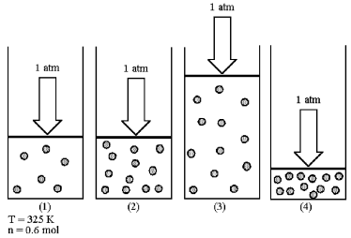

* 1. Diagram (2)
  2. Diagram (3)
  3. Diagram (4)
  4. Unable to determine from data

1. Mendeleev arranged the elements according to
   1. atomic number and atomic weight.
   2. electron configuration and atomic weight.
   3. atomic weight and chemical reactivity.
   4. physical state and relative abundance.
2. Assume that you have a mixture of nitrogen (molecular mass = 28 amu), represented by unshaded spheres, and chlorine (molecular mass = 71 amu), represented by shaded spheres at 300 K. Which of the drawings best represents the mixture?

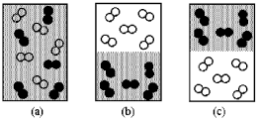

* 1. Drawing (a)
  2. Drawing (b)
  3. Drawing (c)
  4. Unable to determine

1. What is a quantum of light called?
   1. the amplitude
   2. the wavelength
   3. a photon
   4. the frequency
   5. a particle
2. The number of orbitals in a given subshell, such as the 5*d* subshell, is determined by the number of possible values of
   1. *l*
   2. *ml*
   3. *n*
   4. *ms*
3. What are the possible values of *n* and *ml* for an electron in a 5p orbital?
   1. *n*= 1, 2, 3,4, or 5 and *ml* = -2, -1, 0, +1, or +2
   2. *n* = 5 and *ml* = -2, -1, 0, +1, or +2
   3. *n* = 1, 2, 3, 4, or 5 and *ml* =1
   4. *n* = 5 and *ml* = 1

Part II – Problems

1. (5 points) A sample of argon gas has a volume of 4.28 L and a pressure of 0.523 atm at 31.4oC. If the pressure increases to 3.27 atm and the temperature decreases to 17.3oC, what is the final volume?
2. (7 points) “Strike anywhere” matches contain the compound tetraphosphorus trisulfide, which burns in oxygen gas to form tetraphosphorus decaoxide and sulfur dioxide gas. How many milliliters of sulfur dioxide, measured at 725 torr and 32oC, can be produced from burning 0.800 g of tetraphosphorus trisulfide?

Balanced equation for the reaction (if you do not know the formulas for the compounds, you may buy them from me for 2 points)

|  |
| --- |
|  |

1. (5 points) Use kinetic molecular theory to explain the change in pressure that results from warming a sample of gas.
2. (6 points) At a given pressure and temperature, it takes 4.55 minutes for a 1.5 L sample of He to effuse through a membrane. How long does it take for 1.5 L of F2 to effuse under the same conditions?
3. (7 points) The specific heat of aluminum is 0.902 J/g oC. When a 35.0 g aluminum statue is heated to 350.0 oC and dropped into a 25.0 g of water at 38.5oC, all of the heat lost by the aluminum is gained by the water. If the heat of vaporization of water is 2260 J/g, how many grams of water will evaporate? (Assume the water is well mixed and the temperature of the water rises uniformly.)
4. (6 points) Calculate Hrxn for 2 NOCl(g) 🡪 N2(g) + O2(g) + Cl2(g) using the reactions below:

½ N2(g) + ½ O2(g) 🡪 NO(g) Hrxn = +90.3 kJ

NO(g) + ½ Cl2(g) 🡪 NOCl(g) Hrxn = −38.6 kJ

1. (8 points) Use bond energies to estimate the energy of the following reaction. (Be sure to pay attention to the balancing!)



1. (6 points) You hold a gram of copper in one hand and a gram of aluminum in the other. Each metal was originally at 0oC. (Both metals are in the shape of a little ball that fits into your hand.) If they both take up heat at the same rate, which will warm to your body temperature first? Explain your reasoning.
2. (8 points) Enormous numbers of microwave photons are needed to warm macroscopic samples of matter. A portion of soup containing 252 g of water is heated in a microwave oven from 20.0oC to 98oC, with radiation of wavelength 1.55 x 10-2 m. How many photons are absorbed by the water in the soup?
3. (10 points) The ionization energy of selenium is 941 kJ/mol.
   1. What is the energy required to eject one electron from an atom of selenium?
   2. What is the frequency of light required to just eject an electron from an atom of selenium?
   3. What is the wavelength of this light?
   4. What frequency of light would be required to eject an electron with a kinetic energy of 5.4 x 10-19 J?
4. (6 points) Give a possible set of quantum numbers for an electron in the following orbitals:

|  |  |  |  |
| --- | --- | --- | --- |
|  | **6d** | **4s** | **7p** |
| ***n*** |  |  |  |
| ***l*** |  |  |  |
| ***ml*** |  |  |  |
| ***ms*** |  |  |  |

1. (5 points) What physical meaning is attributed to the square of the wave function ψ2?